**LOGIN PAGE:**

**Case1: Valid Scenario for Login:**

**Case 2: When Email Id is empty:**

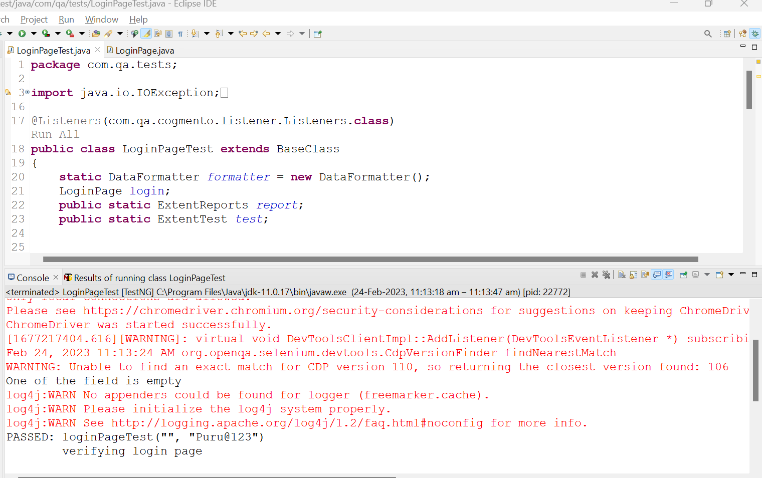

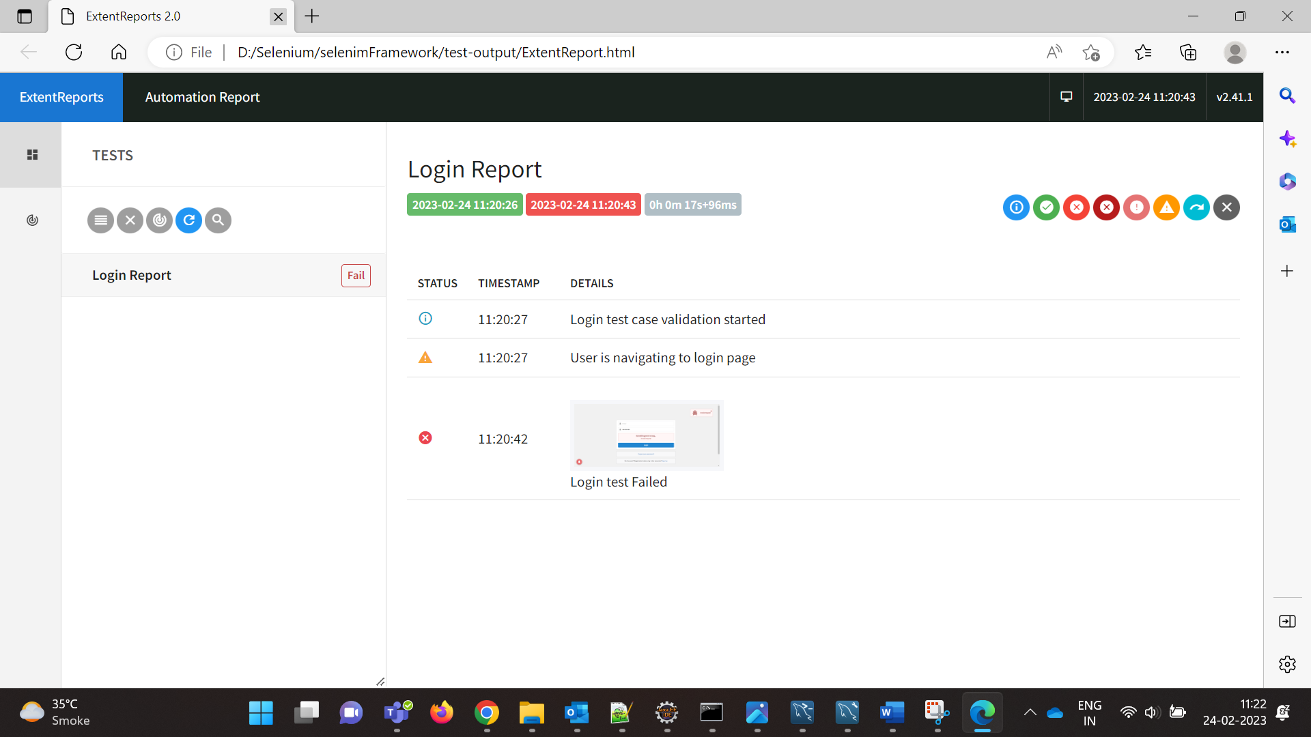

**Case 3: When Password is empty.**

**Case 4: When user provides invalid credentials.**

**(Invalid EmailId):**

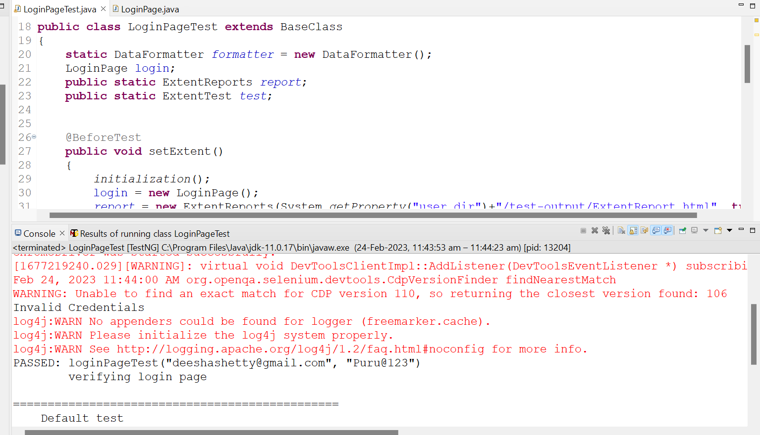

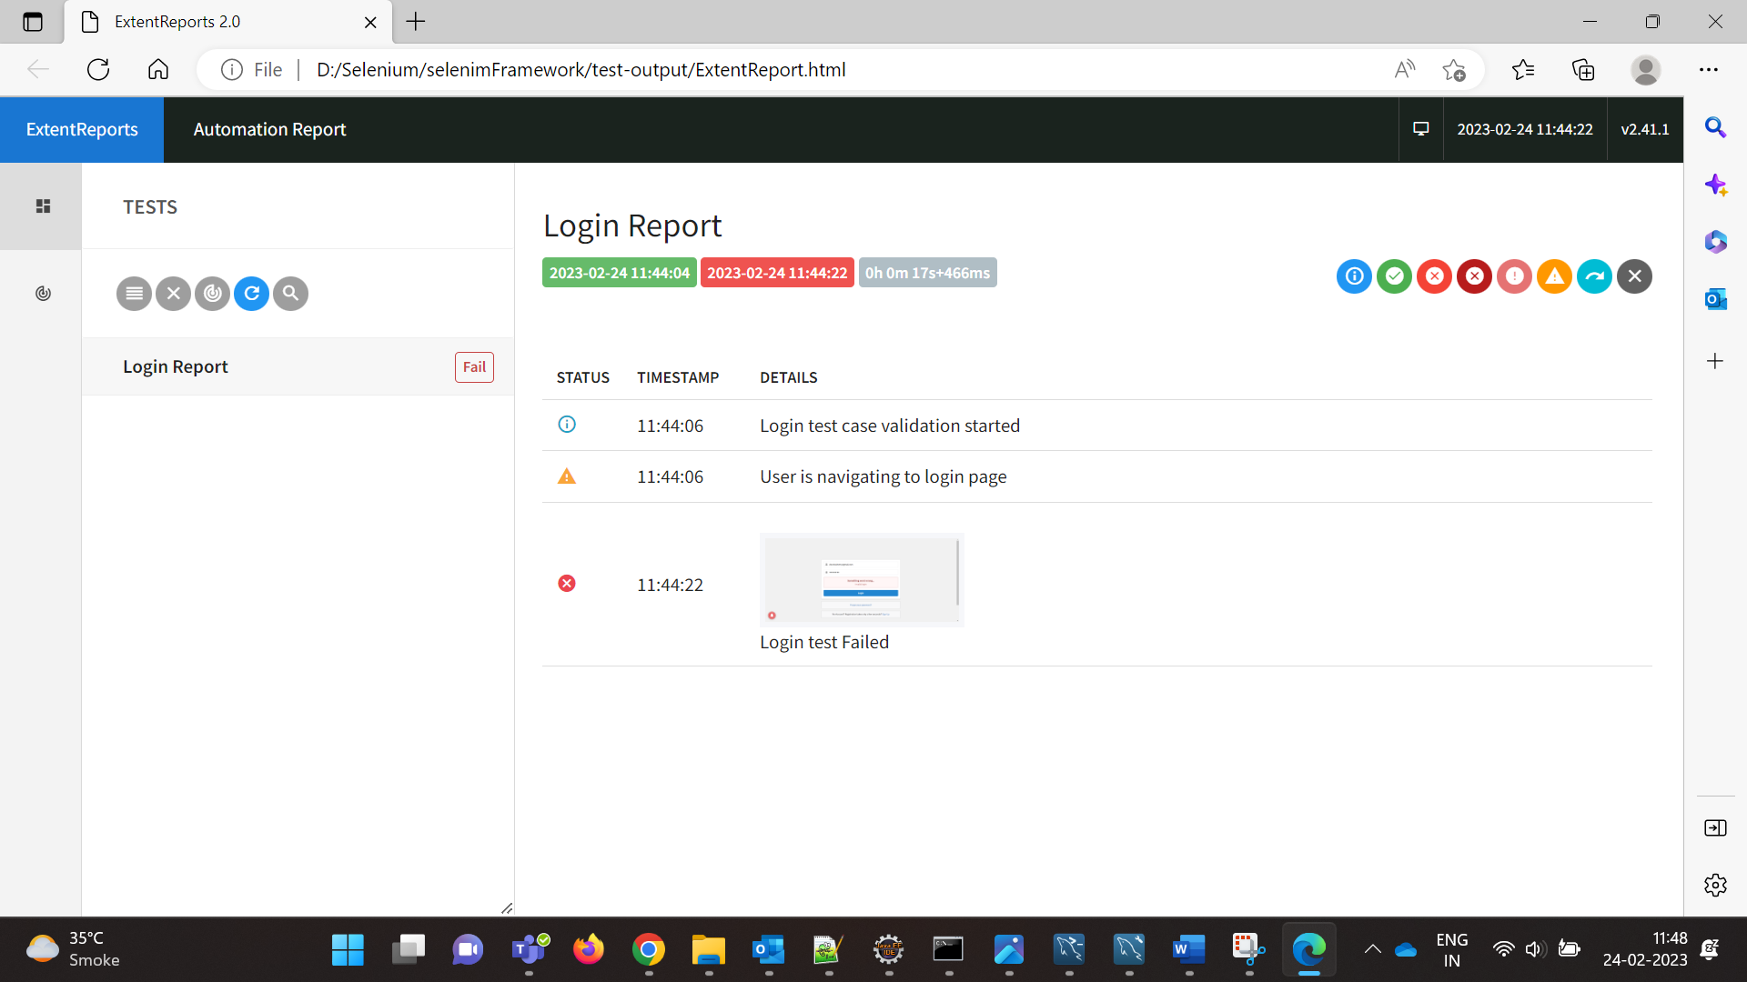

**(Invalid Password):**



